**User manual**

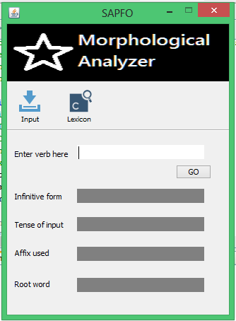

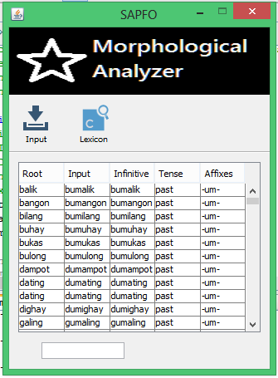

**Lexicon Interface**

**Input Interface**

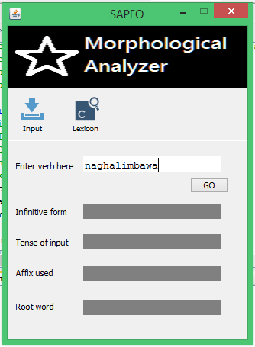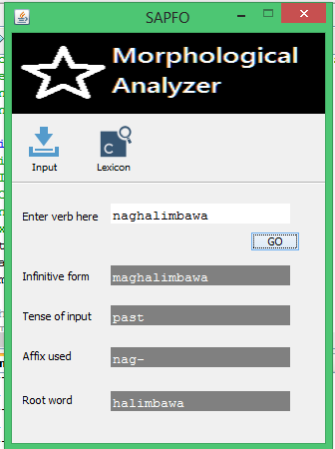

**Legends:**

**1 to go to input interface**

**2 to go to lexicon interface**

**3 textbox for inputted verb**

**4 to generate the inputted verb**

**5 textbox where infinitive form show**

**6 textbox where tense show**

**7 textbox where affix/s show**

**8 textbox where root woed show**

**3**

**4**

**7**

**5**

**6**

**8**

**2**

**1**

**Step 1**

Input verb

**Step 2**

Click the button GO

**Step 3**

The input interface will automatically generated the result